Template for the proceedings of the 2022 ASNZ conference, Wellington – 10 pages maximum
First author ⁽¹⁾, Second author ⁽¹⁾ and Last Author ⁽²⁾
(1) Affiliation, address, city first and second authors
Email of corresponding author
(2) Affiliation, address, city last author
ABSTRACT
In this paper, we describe the formatting of papers for the Conference of the Acoustical Society of New Zealand. Body text of the abstract should be 9 pt. Times New Roman.

INTRODUCTION
The proceedings are the records of the conference. We are hoping to give these proceedings a single, high-quality appearance. To do this, we ask that authors follow some simple guidelines. In essence, we ask you to make your paper look exactly like this document. The easiest way to do this is simply to type your text directly in this document and save it appropriately. That is Registration Number_surname_ firstname.doc.

PAGE SIZE & PAGE LIMIT
All material on each page should fit within a rectangle of 17 x 25 cm, centered on the page, beginning 1.9 cm from the top of the page and ending with 2.54 cm from the bottom. The right and left margins should be 1.75 cm. The text should be in two 7.8 cm columns spaced 1.3 cm apart with a .5 cm gutter. Camera-ready submissions must be 10 pages in length or less.

TEXT & HEADINGS
For body text, please use a 10-point Times Roman font, or other Roman font with serifs, as close as possible in appearance to Times Roman in which these guidelines have been set. The goal is to have a 10-point text, as you see here. Please use sans-serif or non-proportional fonts only for special purposes. If Times New Roman is not available, try the font named Computer Modern Roman. On a Mac, use the font named Times. Right margins should be justified, not ragged.
The following is an example of what a bulleted list should look like:
- All bullets should start at the same point.
- Spacing between the bullets can vary to produce good column and page breaks.
- The use of hanging indent is recommended.
- Numbered lists should follow similar layout

TITLE AND AUTHORS
The title (Arial 18-point bold), authors’ names (Arial 12-point-Bold) and affiliations (Times New Roman 9-point) run across the full width of the page. We request the e-mail address for the corresponding author.

SUBSEQUENT PAGES
For pages other than the first page, start at the top of the page, and continue in double-column format. The two columns on the last page should be as close to equal length as possible.
Table 1. Example of table.
List 1 | List 2 | List 3
A | Colors are OK | Bold is OK
B | Italic is OK | Left flush is OK
C | Merged cells are OK

REFERENCES AND CITATIONS
Footnotes should be Times New Roman 8-point, and ragged right. Ragged right was decided because of many web addresses being used.
References should use the IEEE numbered referencing style using numbers in brackets [1]. A list of references must be provided at the end of the paper. The list should be arranged in the order of citation in text, not in alphabetical order. When repeating a citation, use the original citation number allocated to that reference. Further explanation is provided at https://guides.lib.monash.edu/citing-referencing/ieee. The body text of the citation/references section should be 9 pt. Times New Roman justified.
References should be published materials accessible to the public. Internal technical reports may be cited only if they are easily accessible (i.e., give the address to obtain the report within your citation) and may be obtained by any reader. Private communications can be acknowledged, not referenced (e.g., “[Robertson, personal communication]”). Proprietary information may not be cited.
Do not include headers, footers or page numbers in your submission. These will be added when the publications are assembled.

FIGURES/CAPTIONS
Place tables/figures/images in text as close to the reference as possible (see Figure 1). Figures may extend across both columns to a maximum width. Colors graphs and figures are acceptable.
Figure 1. An example of Figure caption.
Captions should be Time New Roman bold 9-point. They should be numbered (e.g., “Table 1” or “Figure 2”). Please note that the words “Table” and “Figure” are spelled out. Figure captions should be centered beneath the image or picture, and table captions should be centered above the table body.

SECTION HEADS
The heading of a section should Arial Bold 10-point bold, in all-capitals flush left with an additional 12 points of white space above the section head. Sections and subsequent subsections should flush left.

Subsections
The heading of subsections should be in Arial 10-point bold with only the initial letters capitalized. For subsections and subsubsections, a word like the or a is not capitalized unless it is the first word of the header.

Subsubsections
The heading for subsubsections should be in Arial 9-point with initial letters capitalized and 6 points of white space above the subsubsection head.

EQUATIONS
Equations should be written with an appropriate equation editor (i.e. Microsoft Equation Editor or MathType). Equations should be left flushed and numbered in brackets at the end of the line as shown below.
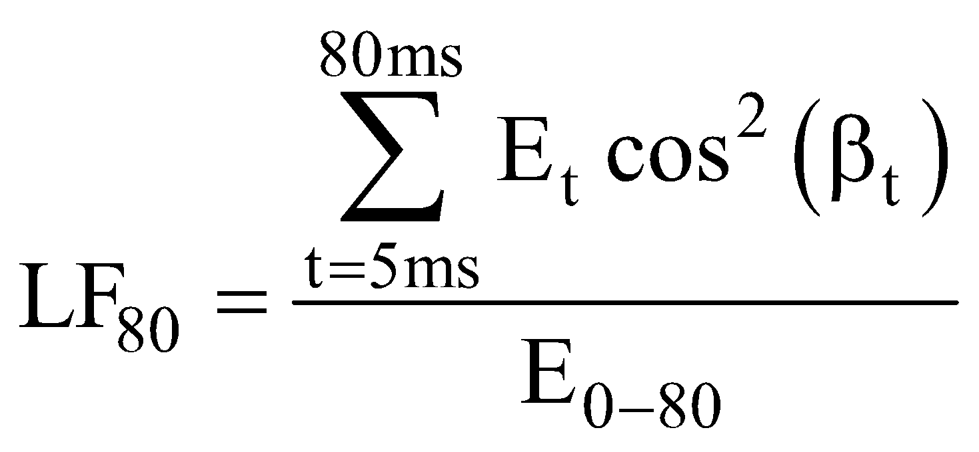 (1)
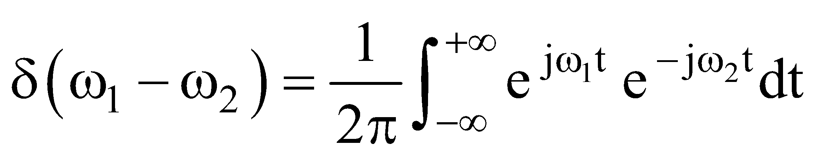 (2)
The size of the symbols should be defined in the equation editor as follows: Full script 10 pt, Subscript and Superscript 7 pt, Sub-Subscript/Superscript 5 pt, Symbol 16 pt and Sub-Symbol 10 pt.

ACKNOWLEDGMENTS
Your appreciation to employers, co-workers, department heads, and/or institutions that issued you a grant can be acknowledged in this section.

REFERENCES

[1] D. R. Kornack, and P. Rakic, "Cell Proliferation Without Neurogenesis in Adult Primate Neocortex," Science, vol. 294, no. 5549, pp. 2127-2130, Dec. 2001.
doi: 10.1126/science.1065467.
[2] G. O. Young, “Synthetic structure of industrial plastics,” in Plastics, vol. 3, Polymers of Hexadromicon, J. Peters, Ed., 2nd ed. New York: McGraw-Hill, 1964, pp. 15-64.

This is an example of footnote text formatting.

